**TECHNICAL CLUB**

[**SLIET Software Development Club**](http://sliet.ac.in/software-development-club/)

|  |
| --- |
|  |

***Objective:-***

1. To enhance students’ programming skills and algorithm concepts through programming and algorithm classes.
2. To motivate students to learn things together and develop some projects based on real-world problems.
3. Students get a job offer through online coding competitions of different companies (TCS, Infosys, ICPC, etc.)

***About:-***

SLIET software development club (SSDC) motivates students for niche and innovative software developments. The SSDC act as a spurring ground for beginner-level programmers with the motive to increase their awareness and knowledge about new technologies. The club motivates its members for competitive programming and various online challenges like hackathons, and online placement drives. SSDC club activities include online contests and discussion sessions on programming. Apart from this, weekly discussion sessions are also conducted by senior students to improve the programming skills of peers and share new innovative ideas to solve various real-world problems.

|  |  |
| --- | --- |
| **Faculty Advisor** | **Dr. Manoj Kumar Sachan, Professor (CSE)** **Mobile No. 9463067527** **Email Id: – manojsachan@gmail.com, manojsachan@sliet.ac.in** |
| **Faculty Co-Advisor** | **Mr. Rahul Gautam, Assistant Professor (CSE)** **Mobile No. 9041513484** **Email Id: – inform2rahul@gmail.com,** |
| **Student Advisors** | **Mr. Arvind Kumar (Guest Faculty)** **Mobile No. 9056341148** |
| **Name of Student Coordinator / President** | **Ms. Mrinalini Pratap Singh** **Regn. No. GCS/1940036** **Mobile No. 8317085231**  **Mr. Sahil Sharma** **Regn No. GCS/1940031** **Mobile No. 6284132687** |

**Club Activity:**

|  |
| --- |
|  |
| **DSA Workshop** |
| A full-fledged workshop on Data Structure and Algorithm along with practical sessions for a period of 14 days. This workshop helps in attaining the concise concepts of data structure and algorithm from scratch and thus will be an asset for the future productivity of your technical knowledge. **– Date:** 25/09/2022 – 8/10/2022 **– Duration:** 14 days **– Participants:** 80 – 120 |
|  |
|  |
| **MindStormer Coding Challenge** |
| An online coding competition that aims at brushing the problem-solving skills of students and implementation of various algorithms. It is conducted online on the “Hackerrank” platform. In this competition, 6 problems had been given to each participant and the participant can solve them in any programming language. **– Date:**10/09/2022 **– Duration:** 12 hours **– Participants:** 55 – 110 |
|  |
|  |
| **Code Drift 2.0 Coding Challenge** |
| An online coding competition that aims at brushing the problem-solving skills of students and implementation of various algorithms. It is conducted online on the “Hackerrank” platform. In this competition, 6 problems had been given to each participant and the participant can solve them in any programming language. **– Date:** 22/06/2022 **– Duration:** 3 – 4 hours – **Participants:** 45 – 50 |
|  |
|  |
| **C Language Workshop** |
| A full-fledged workshop on C language along with practical sessions for a period of 14 days. This workshop ingains the concise concepts of C language from scratch and thus will be an asset for the future productivity of your technical knowledge. **– Date:** 02/03/2022 – 15/03/2022 **– Duration:** 14 days – **Participants:** 50 – 80 |
|  |
|  |
| ***During the academic year 2018-19.*** |
| This is an online programming competition, which is conducted on online “Hackerrank” platform. In this competition 6 problems of programming had been given to each participant and participant can solve in any of the programming language. **Date**:10/8/18, **Duration**: 48 hrs. **No of participants**:24 Url:[*https://www.hackerrank.com/ssdc-pa-1*](https://www.hackerrank.com/ssdc-pa-1) |
| **Mathematics competition:** |
| This is an online programming competition, which is conducted on online “Hackerrank” platform. The purpose of this event is to increase the coding skills with Mathematics logic in programming. **Date** :06/10/18, **Duration:** 24 hrs. **No of participants**:20 Url: [*https://www.hackerrank.com/ssdc18-19-a*](https://www.hackerrank.com/ssdc18-19-a) |
| **Code_camp1:** |
| This is an online programming competition, which is conducted on online “Hackerrank” platform. In this competition 6 problems of programming had been given to each participant and participant can solve in any of the programming language.  **Date**: 19/01/19**,**  **Duration:** 48 hrs**,**  **No of participants**:20  Url :[*www.hackerrank.com/code-camp1*](http://www.hackerrank.com/code-camp1%0d%0d) |
| **CodeBaton:** |
| This is an online programming competition, which is conducted on online “Hackerrank” platform.  This is a Team event. Each team consists of 3 members. In this competition 3 problems based on Mathematics had been given to solve in any of the programming language.  **Date :**15/03/19, **Duration:** 3 hrs., **No of participants:** 45(15 teams)  **Url:**[*https://www.hackerrank.com/codebaton*](https://www.hackerrank.com/codebaton) |

**Members List**

|  |  |  |  |
| --- | --- | --- | --- |
| **Name of Students** | **Registration No.** | **Name of Students** | **Registration No.** |
| Devendra Kumar | GCS/1640113 | Anuj Kumar Kewat | GCS/1640067 |
| Satyam kumargupta | Gcs1731349 | Amarjeet Sinha | DCS/CDE 1712514 |
| Ankit kumar | GCS/1840028 | Soni Kumari | GCS/1830068 |
| Karan | Gcs-1730961 | Rohit kumar | GCS/1840041 |
| Amritanjali | Gec1740631 | Aryan Yadav | GCS/1740694 |
| Ankit Katoch | GCS/1830064 | adityaprakash | GCS/SL/15/4002 |
| Raj Abhishek Maurya | Gcs1840046 | Abhishek kumar | DCS-CDE/1712875 |
| DILKHUSH KUMAR | Gcs/1740652 | Priya | GCS/1830061 |
| Abhimanyu kumarsingh | Gcs1731348 | Naman Singh | GCS/1840007 |
| Nikhil Gupta | GCS1740695 | Shyam Kumar | GCS/1731373 |
| Sumit Kumar | GCS1830024 | Shweta Kumari | DCS-CDE/1712728 |
| Satish Kaushik | GCS/1740603 | AsthaAahana Thakur | GCS/1731315 |
| Chandan Kumar | Gcs/1830067 | Dipayan Das | GCS/1740558 |
| Sumit Kumar | GCS/1731351 | Adish Jain | GCS/1840012 |
| Rajan | Gcs/1740585 | Achyut Saxena | GCS/1640064 |
| Rupam Kumari | Gcs/1740692 | Sweta | GCS/1731325 |
| Vaibhav raj | Gcs/1712007 | Raubinsh Arya | GCS/1731354 |
| Anil Kumar | Gcs/1640151 | Harshit Udainiya | GCS/1640048 |
| Shrawan Kumar | GCS/1840036 | Vivek sharma | GCS/1730958 |

Some students of this club who got the employment offer letter in companies like TCS, INFOSYS,AASHRAY etc. are as follow.  
1. Aditya Prakash (GCS/SL/15/4002)  
2. Umang Patel (GCS/SL/15/4023)  
3. Narender Singh (GCS/SL/15/4009)  
4. Saket Kumar (GCS/Sl/15/4043)  
5. Akshay Tyagi (GCS/SL/4021)  
6. Lokpati Mishra (GCS/SL/4107)  
7. Nilesh Kumar (GCS/SL/4026)

[**SLIET Robotics and Automation Society(SRAS)**](http://sliet.ac.in/sliet-robotics-and-automation-societysars/)

***Objective:-***  
To aware students regarding the latest in the field of Robotics and Automation

|  |  |
| --- | --- |
| **Faculty Advisors** | **Dr. Asim Ali Khan, Associate Professor (EIE)** Mob. no.:  81460-33455 e-Mail: [asimsliet@gmail.com](mailto:asimsliet@gmail.com) |
| **Student Coordinators** | **Sudhanshu Kumar** Mob. no.: 89358-44961 e-Mail: sudhanshukumar2759@gmail.com |
| **Shubham Mahajan** Mob. no.: 97360-62477 e-Mail: mahajanshubhi01@gmail.com |

[**Endeavour Society**](http://sliet.ac.in/endeavour-society/)

***Objective:-***

1. To be able to understand different technology stacks used in robotics, outside their regular curriculum.
2. To reinforce the technical prospect of students, enabling them to become refined concocts having knowledge of diverse fields.

|  |  |
| --- | --- |
| **Faculty Advisor** | **Dr. Amrik Singh, Associate Professor (Mech. Engg.)** Mob. no.: 94630-67535 e-Mail: hanspalamriksingh@gmail.com |
| **Student Coordinators** | **Pandrangi Kalyan** Mob. no.: 84274-03319 e-Mail: pandrangikan123@gmail.com |
| **Shubhi Sharma** Mob. no.: 91317-68992 e-Mail: shubhisharma0016@gmail.com |

***Certificate of Merit***

|  |
| --- |
|  |

|  |  |  |  |  |
| --- | --- | --- | --- | --- |
| **Title of the innovation** | **Name of the Awardee** | **Name of the Awarding Agency with contact details** | **Year of Award** | **Category- institution/teacher/research scholar/student** |
| e-Yantra Robotics Competition (eYRC | 1. Mahesh Yadav | ERTS Lab | 2021 | Student |
| 2020-21) held on March 30th to April 3rd, 2021 online. | 2. Princu Singh | Department of Computer Science and Engineering |  | **ENDEAVOUR Society** |
|  | 3. Vimal Kumar Verma | Indian Institute of Technology Bombay, |  |  |
|  | 4. Shivotkarsh Raj | Powai, Mumbai-400 076. |  |  |
|  |  | e-Yantra is a project sponsored by MHRD, Government of India, under the National Mission on Education through |  |  |
|  |  | ICT (NMEICT) |  |  |

[**IEEE Student Branch-SLIET**](http://sliet.ac.in/ieee-student-branch-sliet/)

***Objective:-***  
Inspire, Enable, Empower and Energize our student members to enhance their technical interests by providing them a platform to show case their skills.

|  |  |
| --- | --- |
| Faculty Advisor | **Dr. Ashwani Kumar Aggarwal** **Mobile No. 95305 30190** **ashwani.ist@sliet.ac.in** |
| Student Name | **Raushan Kumar** **GEE/121739** |

**Club Activities**

|  |
| --- |
| Govt. School visit in Duggan on 31/10/2018 under Village Development Programme |
|  |
| Two-day workshop on MATLAB April 28th and 29th, 2018 |
|  |
| The institute celebrated National Technology Day on 11 May 2022 on the theme “Integrated Approach in Science and Technology for Sustainable Future”. Dr. Arun K. Singh, Chair IEEE Chandigarh Subsection delivered an interactive talk on “Nanotechnology for Futuristic Applications”. Dr. Dipanwita Haldar, Scientist, Indian Institute of Remote Sensing, Dehradun delivered talk on “Remote Sensing Technology for Agriculture” and interacted with the participants. The event was coordinated by Dr. Ashwani Kumar Aggarwal, IEEE Branch counsellor at SLIET. |
|  |

***Activities:***

* Two-day workshop on MATLAB April 28th and 29th, 2018
* Modular Course on Programming in MATLAB started on August 11, 2018
* Govt. School visit in Duggan on 31/10/2018 under Village Development Programme
* One day workshop on Space Science Research on January 8, 2019 jointly with SAC, ISRO, Ahmedabad.

[**Indian Society for Technical Education(ISTE)**](http://sliet.ac.in/indian-society-for-technical-educationiste/)

***Objectives:***

* To provide platform for students to showcase their talents especially on technical fields.
* To provide training to the students and encouraging innovation and excellence in students.
* To enhance student’s professional ideals & standards

|  |  |
| --- | --- |
| Faculty Advisor | **Mr. Harish Arya, A.P. (Mech.)** **Mobile No. +91 9988525366** **Email Id: arya.iitr@gmail.com** |

***Club Activities:***

|  |
| --- |
| **Engineer Day on Dated 16.09.2022** |
|  |

**Activity Report 2018-19**

1. Hostel Quiz  
2. Brain Storming  
3. Departmental Face-off  
4. Tech-Auction

**2. Brain Storming**

Main things is that, play with mind.  
Group type event with 3-4 members  
# Round 1 {Quizmaniya}  
Questions are in quiz type in group  
# Round 2 {Multimedia(Audio $ Video Round)}  
# Round 3 {Verbal Questioning Round}  
Different type of Question are verbally asked related to Science $ technology.  
# Round 4 {Talent or Decided Round}

After All three round Completed, to Decide the winner this round held…

**3. Departmental Face-off**

It is the competition between all the departments. Each dept. has 10 selected students on the basis of screening round.  
Then, these 10 students represent their dept. in competition.  
The Score will display on display board every day.  
# Round 1 {SCREENING QUIZ (Pre-Event)}  
On the basis of quiz, 10 students were selected from each dept.  
#Round 2 {PRACTICAL KNOWDLEDGE (On Tech-fest)}  
Face to Face.(oral type)  
Questions are based on practical knowledge of their respective department.  
#Round 3 {Theory Knowledge}  
Questions are based on theory of their respected dept.  
#Round 4 {General Round}  
Questions is open to all related to GK $ GS.  
After every round their open session round in which any student of their dept. take part to rise their dept.

**4.Tech-Auction**

In this event ever student who participate allotte some credit…that they use at all  
booth or stall …..now the stalls are related to all the types like computer science stalls  
Ec ee etc ….at all stalls there is some kind of competition will be there that they have to  
take on bt by giving there credit that we already given them….in such a manner all the  
participants move to all the stalls and earn as much bucks they can…yes at every  
successfully completing there work that is at stall we will provide them bucks according  
to the competition type …and that bucks that they are earning will be use at the last  
…in auction where they avail there bucks to buy there winning gift …  
so clearly those who earn more are the winner  
Participants types(ICD/UG/PG):-ICD & UG  
Rules of Event:-3 or 2 or 1 participant are allowed..nd rest of the rule will be explained  
at the time of event  
Judgement criteria:- who buy the winning gift is the winner

[**SAE India SLIET Collegiate Club**](http://sliet.ac.in/sae-india-sliet-collegiate-club/)

***Objectives:***

* To design, manufacture and test run the vehicles.
* To conduct competitions and provide first hand challenge to students for  preparing them for participation in National level events.
* To facilitate students in pursuing their passion while managing real life  demands and educational priorities.

|  |  |  |
| --- | --- | --- |
| **Faculty Advisor** | **Team** | **Student Coordinators** |
| **Prof. Shankar Singh** **(Mechanical Engg)** **Mobile No. 9465251439** **E-mail: singh.shankar@gmail.com** | Junkyard Warriors | Ankit Kumar Gurjit Singh |
| Team JUGGERNAUTS | Ashish Kumar Vivek Rai |
| Green Rangers | Varun Prajapati Lovepreet singh Sarao |

**Activity Report Participation & Awards Won**

**BAJA SAE India 2019**(6th -10th March 2019)

**Awards Won alongwith prize money:**

* 1st in Durability Award
* Pride of Punjab Winner

**Mega ATV Championship (Goa) (17th March -20th march 2019)**

**Award Won**2nd Runnerup in Flat Dirt race

**Aravalli Terrain Vehicle Championship (ATVC), Kota (Raj.)**(25th February – 1st March 2019)

**Awards Won alongwith prize money:**

* Overall 2nd position
* First Endurance race
* Best Driver award
* First runner up in Suspension and Traction
* First runner up in Maneuverability

Second runner up in Acceleration

**Efficycle 2018 (9th -13th October 2018)**

**Awards Won alongwith prize money:**

* Overall winner
* 1st in endurance race
* 1st in cost award

1st in drive excellence.

**Eco Green Vehicle Challenge (EGVC 2019)**

**(3rd- 6th April 2019)**

**Awards Won alongwith prize money:**

* Overall Winner
* Endurance award
* Maneuverabilty Award

Design runnerup award

**7th Season of International Go Kart Championship (IGC – 2019) (15th-18th March 2019)**

**Awards Won alongwith prize money:**

* Overall 2ndRunners up
* Best build quality winner
* Endurance 1st Runners up

**Go Kart Design Challenge season 6 (22nd -27th Feb, 2019)**

**Awards Won alongwith prize money:**

* Design Evalution – 3rd
* Disassemble test – 2nd
* Acceleration – 3rd
* Autocross – 3rd
* Skidpad – 3rd
* Endurance Race– 4th
* Overall – 4th
* Maximum speed attained by our Go Kart in the Endurance race is 100 kmph

**Indian Karting Championship,Season3,2019(13th -17th Feb,2019 )Awards Won alongwith prize money:**

Secured Overall Rank 15 among 155 teams

Team ‘Juggernauts’ also participated in **Go Kart Design Challenge Season 6 – 2018 (ANNEXURE-A)**, at Buddh International Circuit, Noida from February 22, 2019 to February 27, 2019.

**Performance at the Event**

The SLIET team performed well at Buddh International Circuit and SLIET Go Kart ‘Zorawar’

(Kart No. #10) secured the following ranks –

1. Design Evolution – 3rd
2. Disassemble test – 2nd
3. Acceleration – 3rd
4. Autocross – 3rd
5. Skidpad – 3rd
6. Endurance Race– 4th
7. Overall – 4th

Maximum speed attained by our Go Kart in the Endurance race is 100 kmph

Team ‘Juggernauts’ also participated in **‘3rd Season of Indian Karting Championship’ at Mohite Racing Academy, Kolhapur, Maharashtra, from February 13, 2019 to February 17, 2019**

**Performance at the Event**

Secured overall Rank 15 among 155 teams.

[**Mavericks Club**](http://sliet.ac.in/maverics-club/)

[](http://sliet.ac.in/wp-content/uploads/2023/02/Mavericks-Logo.png)

***Mavericks Club***:

It provides an ideal platform for students of Mechanical, Mechatronics, Electronics, Computers and Electrical Engineering background to hone their skills and showcase their talent in many interdisciplinary activities.

***Objectives:***

• To promote creativity and to increase the technical know-how and productivity of all the students at the Institute under one umbrella.  
• To promote hands-on and co-operative learning and also engages students in problem solving and higher order thinking for Industrial Oriented Projects & preparation for     various competition organized all over India.  
• To develop the spirit of entrepreneurship among the students of Institute.

**About:**

Team Mavericks officially came into existence in September 2017 for exploring robotics and automation engineering by Founders – Kaushik Suman , Dhruv Patel, Umang Patel, Ashutosh Singh & Shivanshu Srivastava. Our Team works on Projects that fits the Industry requirements & it also get funds from Institute for development by Institute Innovative Cell.

|  |  |
| --- | --- |
| **Faculty Advisor/Co-Ordinator** | **Prof. J.S. Ubhi (ECE Dept.)** Mobile No. 9463068009 js_ubhi@yahoo.com |
| **Students Coordinator** | **Prashant Sharma** Mobile No. 8393021054 2040301@sliet.ac.in  **Bhawana Sinha** Mobile No. 9060009605 bhawanasinha13@gmail.com |
| **Event Coordinator** | **Ram Kumar** Mobile No. 6203884073 2040367@sliet.ac.in |

***Club Activities:***

|  |
| --- |
| **Techfest Projects-**Team Mavericks provides platform & empowers its team member to participate in Tech-fest events for innovation & to develop team spirit & leadership. |

|  |  |
| --- | --- |
|  |  |

|  |  |  |
| --- | --- | --- |
|  |  |  |

|  |
| --- |
| **3-D Printing Workshop** – The members of Team Mavericks has designed its own 3d-Printer & even conducts 3D-Printing Workshop for students. |

|  |  |  |
| --- | --- | --- |
|  |  |  |

|  |
| --- |
| **Trainings & Seminars –**Team Mavericks often conducts Seminars & Training Classes for its newly recruited members. |

|  |  |
| --- | --- |
|  |  |
|  |  |

|  |
| --- |
| **Aptitude Test** –Team Mavericks conducted Aptitude test for recruitment & Rank holders received Robotic-Kit as prize. |

|  |  |
| --- | --- |
|  |  |

|  |
| --- |
| **PPT Presentation** –Team Mavericks conducts PPT presentation for improvement in presentation skills. |

|  |  |
| --- | --- |
|  |  |

**Our Achievements:**

• Won in Smart India Hackathon (SIH) in 2019, 2020.  
• Two teams qualified for the zonal rounds of DRDO’s Unmanned Vehicle Challenge.  
• Among the top teams in the E-YANTRA 2017, 2018, 2019 competition jointly by Ministry of Education, MoE (Formerly:MHRD) and IIT, Bombay in 2017, 2018, 2019.  
• Spreaded glories at various technical fests, including IIT Bombay , IIT Kanpur , IIT Delhi , IIT BHU , IIT Ropar , PEC , Thapar University & received cash prize at GNDU      Amritsar.

**Our Team:**

|  |  |  |
| --- | --- | --- |
|  |  |  |

**Meetings during pandemic period with Worthy Director, Prof. Shailendra Jain**

|  |
| --- |
|  |

[**HackTekers**](http://sliet.ac.in/hacktekers/)

[](http://sliet.ac.in/wp-content/uploads/2022/12/Hacktekers.jpg)**Objectives**

1. Introducing a community for Cyber Security Enthusiast.
2. Help degree students for better Skillset and Career Opportunity.
3. Providing better path for Certifications and License.
4. Affiliating our College with World’s Renowned Cyber Communities.
5. Collaborating with other top Institute’s Communities.

For more info please visit: http://www.hacktekers.org/

| **Contact** | **Information** |
| --- | --- |
| **Faculty Advisor** | Dr. Anupma Marwaha, Prof. (ECE) Mobile No. 9872224055 Email Id:–marwaha_anupma@yahoo.co.in |
| **President** | Rishav Kumar, (GEC-2030569) Mobile No. 7004652649 EmailId:– rishavkumar9713@gmail.com 2030569@sliet.ac.in |
| **Vice-President** | Amarjeet Sinha, (GCS-2030487) Mobile No.  7011098333 EmailId:– sinha9amarjeet@gmail.com 2030487@sliet.ac.in |

**SOCIAL CLUB**

[**NSS**](http://sliet.ac.in/nss/)

**Objectives:**

1. Personality development of students through community service.
2. Providing opportunity to students for participation in planning and development activities.
3. Emphasizing dignity of labour and self-help “Not Me But You”

|  |  |
| --- | --- |
| **Faculty Advisor** | **Dr. Gulshan Jawa, Associate Professor (Chem. Engg.)** Mob. no.: 94631-67202 e-Mail: gulshanjawa@yahoo.co.in |
| **Student Coordinators** | **Somesh** Mob. no.: e-Mail: |
| **Ajit Kumar** Mob. no.: e-Mail: |

[**SLIET Electoral Literacy Club**](http://sliet.ac.in/sliet-electoral-literacy-club/)

**Objectives:**

1. Strengthening the culture of electoral participation among young and future.
2. To educate students, faculty and staff about voter registration procedure.
3. To develop a culture of electoral participation and maximize the informed and ethical voting.

|  |  |
| --- | --- |
| **Nodal Officer** | **Dr. J.S. Gill, AsP (Mech. Engg.)** Mob. no.: 94172-70370 e-Mail: jsgillsliet@yahoo.co.in |
| **Student Coordinators** | **Sumit Saini** Mob. no.: 85284-34049 e-Mail: sumitmeghraj@gmail.com |
| **Srishti Gaba** Mob. no.: 70172-70524 e-Mail: srishtigaba662@gmail.com |

[**Happy Club**](http://sliet.ac.in/happy-club/)

***Objective:***  
Social Work and Personality Development.

***About:***

Smile is something that makes you to be unique. There are many languages on earth but Smile is something that speaks them all. This club is dedicated to all those who want to be keep smiling and want to share that smile with you.

Happy Club is the social and literary intra university club of SLIET UNIVERSITY located in Longowal village District: Sangrur, Punjab. It is purely run by students of university under the supervision of higher authority.

The club works on the theme “SPREAD SMILE” and club is moving towards happiness. The club is strictly oriented with its theme and growing qualitatively. The committee consists of certain volunteers throughout the institute; these volunteers are elected by the higher authorities according to their interests and skills. All are willing to take initiative and shows the positive response towards the work assigned. Works are properly distributed according to capability of the students.

The club does social works in contiguous villages and NGOs around the university and organizes various competitive activities and events to refresh the minds of students such as FUN GAME, QUIZZES, MARATHON and BLOOD DONATION CAMPS etc. within the campus. The club collects the reusable materials from the students and donates to needy peoples. The funds collected in various events and activities are used to run the club and donate to needy persons.

In year 2016, an initiative was taken by happy club to educate the underprivileged kids of the labours and other construction workers. This move was named as koshish–ek nayi udaan ki. Under this kids were not only learning but also admitted in the local school. This move is regarded as a most appreciated work for a noble cause.

|  |  |
| --- | --- |
| **Faculty Advisor** | Dr. Yogesh Kapil, A.P. Math |

[**Sviesa– The Photo graphy and Movie club**](http://sliet.ac.in/sviesa/)

***Objectives:***

* -To spread the culture and interest in Photography and Movie
* -Envisaging the outburst of every sort of activity, ranging from workshops, events to every other possible Activity
* -To use photography to the benefit of the community by providing pictorial records of the community, its people and events and its environs

|  |  |
| --- | --- |
| **Faculty Advisor** | **Dr. Ajay Pal Singh, Professor(ECE)** Mob. no.: 9417106644 e-mail: ajaypal@sliet.ac.in |

**CULTURAL**

[**Cultural Committee**](http://sliet.ac.in/cultural-committee/)

***Objectives:***

* To promote ethnicity amongst students by organizing and conducting various events and celebrating the cultural diversity by nurturing the inner talent of students.
* To organize successful annual cultural event to promote Institute in terms of recognition amongst other Institute/University

|  |  |
| --- | --- |
| Convenor | **Dr. Manpreet Singh Manna** Mob. no.: 9815421217 e-mail: mannasliet@gmail.com |
| Co-Convenor | **Dr. Anshuka Bansal** Mob. no.: 9815724373 e-mail: anshuka3@gmail.com |
| Co-Convenor | **Dr. Gurjinder Kaur** Mob. no.: 9417588161 e-mail: gurjinder13@yahoo.com |
| Member | **Sh. Jaspal Singh** Mob. no.: 9876699245 e-mail: safrisoft@yahoo.com |
| Member | **Sh. Manoj Pandey** Mob. no.: 8872500372 e-mail: panaciabt@yahoo.com |
| Member | **Sh. Manjodh Singh Jodha** Mob. no.: 9915900540 e-mail: jodha_3@yahoo.com |

***Club Activities:***

|  |
| --- |
| **1. Independence Day** |
|  |
| **2. Republic Day** |
|  |

[Circular – Student Nomination for Cultural Committee](http://sliet.ac.in/wp-content/uploads/2022/08/Cultural-Committee-Notice.pdf)

[**SPICMACAY**](http://sliet.ac.in/spic-macay/)

[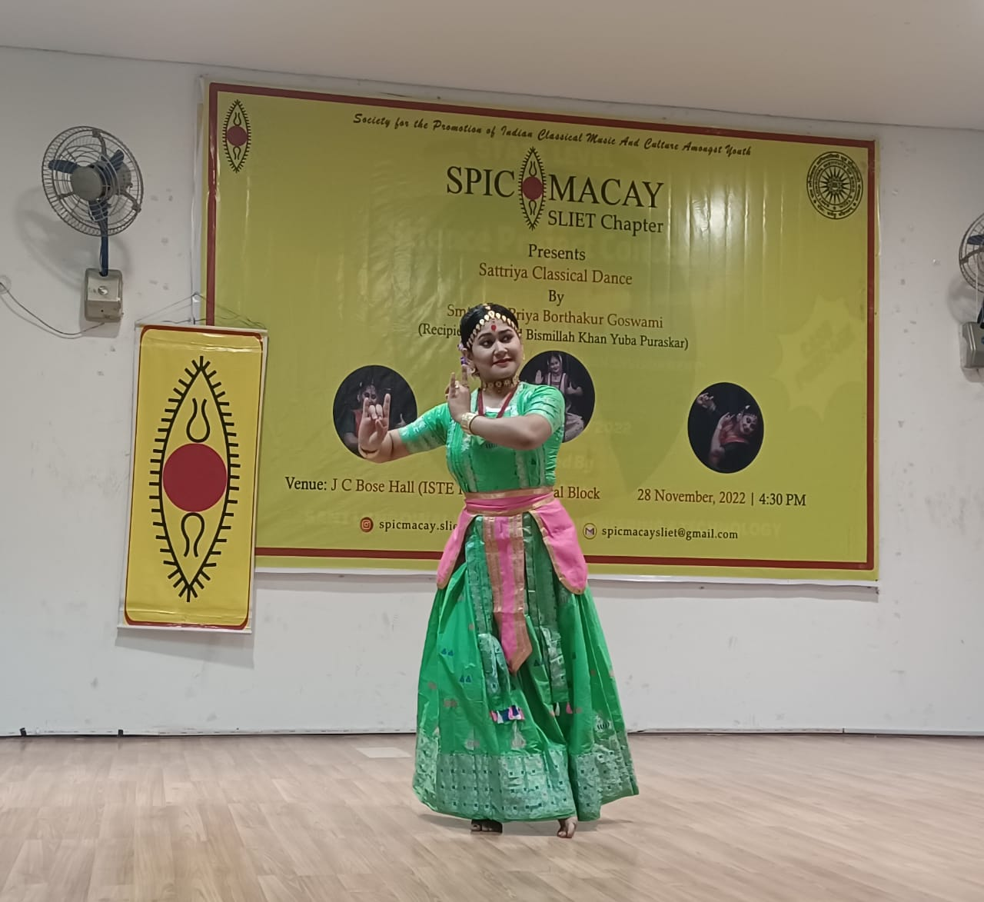](http://sliet.ac.in/wp-content/uploads/2022/11/SPIC-MACAY.jpeg)

***Objectives:***

The Society for the Promotion of Indian Classical Music And Culture Amongst Youth (SPIC MACAY) is a voluntary youth movement which promotes intangible aspects of Indian cultural heritage by promoting Indian classical music, classical dance, folk music, yoga, meditation, crafts and other aspects of Indian culture.

|  |  |
| --- | --- |
| **Chairperson** | **Dr. Kamlesh Kumari, Professor (CE)** Mob. no.: 82890-12315 e-mail: kamlesh213@yahoo.co.in |
| **Co-Chairperson** | **Dr. Prabhdeep Kaur, Asst Prof.(Phy)** |
| **Secretary** | **Mr. Ashwani Kumar, Asst. Prof.(FET)** |
| **Treasurer** | **Dr. Tajinder Singh, Asst. Prof.(CSE)** |
| **Student Secretary** | **Kumari Pallavi,**GCT/2040005 **Priyanshu Pandey,**GEC/2040020 |
| **Student Treasurer** | **Ved Prakash,**GEC/2040009 |
| **Joint Treasurer** | **Shanki Kumar Rawat,**GCT/2040027 |
| **Joint Secretary** | **Tanu Shakya,**GCT/2040005 |
| **Member** | **Arati Gupta,**GCT/2040023 **Natik Raj,**GCT/2130004 **Amit Kumar,**GEE/ 2140315 **Rolly,**CPT/2110039 **Rohit Singh Raju,**CDE/2110227 **Mehakdeep,**CPT/2110001 |

1. [**SPIC MACAY SLIET CHAPTER**](http://sliet.ac.in/wp-content/uploads/2013/12/Spic_macay_sliet_chapter2.pdf)
2. [**Current Event**](http://sliet.ac.in/wp-content/uploads/2022/11/SPIC-MACAY.pdf)
3. [**Gallery SPIC MACAY SLIET CHAPTER**](http://sliet.ac.in/wp-content/uploads/2013/12/spicmacay21.pdf)

## LITERARY[Society of Food Technocrats(SFT)](http://sliet.ac.in/society-of-food-technocratssft/)

|  |  |
| --- | --- |
| Faculty Advisor | **Dr. Pradyuman Kumar** **Mobile No. 8264955480** |
| President | **Ankit Kumar** **(GFT-121344)** |
| Vice-President | **Lucky Kumar** **(GFT-1731932)** |

**Activity**

* On 26.09.2018, an expert lecture given by Dr. Pradyuman Kumar.
* On 2 October 2018, Tree plantation work under SWACHHTA PAKHWARA.
* On 16.10.2018 celebrated World Food Day in Mini auditorium and prize has been distributed to winners of quiz, paper presentation, food product development and, Entrepreneurship for ICD and BE students by Dr. S. S. Marwaha.
* On 23.04.2019, Annual Day of society, prize was distributed to all winners of Food quiz, Indian history quiz, paper presentation, food preneurship, experiment test, multimedia quiz for ICD and BE students by Chief Guest Dr. S K. Jain Director, SLIET.
* On 06.05.2019, Farewell to final year of BE and M Tech batch has been organized.

[**Raj Bhasha Samiti**](http://sliet.ac.in/raj-bhasha-samiti/)

Objective (उद्देश्य)

* संस्थान में विभिन्न राष्ट्रीय भाषाओं को एकात्मकता के सूत्र में पिरोने हेतु संवाहक राजभाषा हिन्दी के रूप में कार्य करती है

|  |  |
| --- | --- |
| **Faculty Advisor** | **Dr. Dr. R.K. Yadav,  Professor (Mech. Engg.)** Mob. no.: 94174-66741 e-mail: rkyd@yahoo.com |
| **Student Coordinators** | **Sundram kumar** Mob. no.: 62800-37962 e-mail: kr.sundram124@gmail.com |
| **Raju Kumar Chaudhary** Mob. no.: 86996-90390 e-mail: chaudharyraju.raju@gmail.com |

***Club Activities:***

|  |
| --- |
| **1. Hindi Diwas** |
|  |
| 2. [Matrabhasha Day Diwas completed on dated 21.02.2023](http://sliet.ac.in/wp-content/uploads/2023/02/Matribhasha-Divas-News.pdf) |
|  |

[**ANSHUMAT News Letter**](http://sliet.ac.in/anshumat-news-letter/)

***Objective:***  
To document different activities taking place in SLIET Longowal and provide a platform to students to present their creativity.

|  |  |
| --- | --- |
| **Editor-in-Chief** | **Dr. Sanjeev Garg,  Associate Professor (M&H)** Mob. no.: 98158-03310 e-mail: gargsanjeev232@yahoo.com |
| **Faculty Advisor** | **Dr. PratibhaTyagi, Associate Professor (EIE)- EIE  Editor Dr. Vinod Kumar  Verma, Assistant Professor (CSE) -CSE and SFW activities Editor Dr. Vinod Kumar Meena, Assistant Professor (CE) – Chem. Engg. & NCC/NSS Editor Mr. Vipul Singhal, Assistant Professor (ECE) -ECE Editor Dr. R. K. Guha, Professor (Maths) -Basic Sciences and Sports Editor Head (T&P)- T & P Editor Dr. Om Chand, Sr. Technician (FET) – Food Engg and Tech. Editor DR (Academics) – Editor (Academic Section) Mr. Sarabjeet Singh , PS** |

[**SRIJAN**](http://sliet.ac.in/srijan/)

[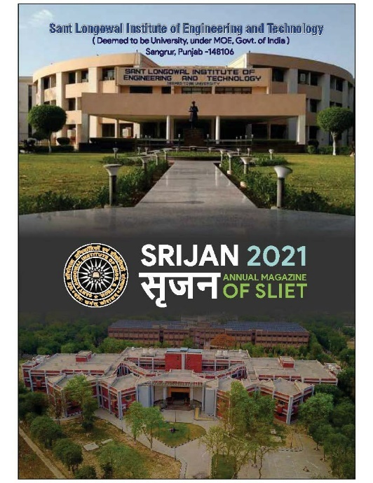](http://sliet.ac.in/wp-content/uploads/2022/11/40.jpg)

|  |  |
| --- | --- |
| **Faculty Advisor** | **Dr. Sanjeev Garg,  AsP(M&H) & Chairman ( Magazine & Profile Committee)** Mob. no.: 98158-03310 e-mail: gargsanjeev232@yahoo.co |
| **Student Coordinators** | **Sushobhit Kumar** Mob. no.: 86993-13991 e-mail: sushobhitkr617@gmail.com |
| **Balraj** Mob. no.: 90415-42991 e-mail: balrajmart@gmail.com |

**SRIJAN STUDENTS’ TEAM**

|  |  |  |
| --- | --- | --- |
| Name | Contact |  |
| Sushobhit Kumar                               GIN16 | 8699313991 | Student Co-ordinator& Technical section Editor |
| BalrajGWT 16 | 9041542991 | Technical section Editor |
| Ashutoshjha                                    GWT 17 | 9015133034 | Co- coordinator Hindi section Editor |
| Kumar Pranshu                                 GME16 | 9525695789 | Hindi section Editor English section Editor |
| ShanurRahman                                 GCS16 | 8699368625 | English section Editor |
| Rahul meena                                   GME 16 | 7814707132 | Designer |
| RipudamanbirSingh  GWT 16 | 6280722267 | Photography |
| MandeepKumar                              MBA 18 | 9465553545 | Punjabi section Editor |
| Neelmanijha                                     GEE17 | 8544042816 | Hindi section Editor |
| Deveshjha                                        GEE17 | 9056353756 | Hindi section Editor |

**COUNSELLING**

About:

[**Counselling**](http://hc.sliet.ac.in/counselling/)

**COUNSELLING FACILITY:**

To make life better, to instill confidence, to provide shoulder for support in times of need, the institute has appointed two visiting counselors for providing counseling facility to students and staff. As per requirement any individual may contact the counselors in the time of need after taking an appointment. Counselors are prepared to deal with problems and issues related to stress, anxiety due to low academic grades, placement issues, low self-confidence, difficulty in mixing with others, feeling of inferiority, family or parental problems, relationship issues, emotional issues, peer pressure resulting into addiction of any kind – alcohol, drug, mobile, gaming etc. The individual will be given session(s) by the counselors and if required may be referred to the Psychiatrist (Doctor). **Information shared by individual remains confidential – No information is shared with anyone.** Parents will, however, be informed in case of referral or an imminent life threatening situation.

1. Appointment can be made as per counsellor’s schedule by meeting personally.
2. Counselors are available in the Health Centre as per following schedule:

**Mrs. Sherrain Rattan      Thursday  4.00 to 6.00 pm**

**Mrs. Harpreet Kaur        Saturday   3.00 pm to 05.00 pm**

1. Counselors also visit different hostels from time to time or as per requirement.